In the name of God

Univrsity of Tehran

Faculty of engineering

Electrical and computer faculty

**Linear control systems lab**

**preLab8**

—

--

Group numb:5

Azar1398

**Contents**

|  |  |
| --- | --- |
| **Title** | **Page number** |
| Part 1 | 3 |
| Part 2 | 4 |
|  |  |
|  |  |

# Part 1

## The effect of PID parameters

|  |  |  |  |  |
| --- | --- | --- | --- | --- |
| Response | $$T_{rise}$$ | $$T_{peak}$$ | $$T_{settle}$$ | $$error$$ |
| $$K_{p}$$ | Small changes | Increase | Increase | Without changes |
| $$K_{i}$$ | Increase | Increase | Decrease | _ |
| $$K_{d}$$ | Small changes | Decrease | Decrease | Without changes |

If we divide PID controller into three parallel controllers {proportional, divider, integrator } with respect to $K_{D}$ changes our system will be more stable , faster and with wider band width. Also in integrator our steady state error will be less and our system will be slower than before.

# Part 2

## PID controller in Matlab

|  |  |  |  |  |
| --- | --- | --- | --- | --- |
|  | $$T_{rise}$$ | $$T_{peak}$$ | $$T_{settle}$$ | $$error$$ |
| $$k_{i}=1,k_{d}=0.47,k_{p}=5.6$$ | 0.904 | 2.074 | 25.53 | 0 |
| $$k_{i}=1,k_{d}=0.47,k_{p}=3.3$$ | 1.199 | 2.759 | 26.579 | 0 |
| $$k_{i}=1,k_{d}=2.2,k_{p}=5.6$$ | 0.445 | 0.937 | 11.387 | 0 |
| $$k_{i}=2,k_{d}=0.47,k_{p}=5.6$$ | Unstable | Unstable | Unstable | $$∞$$ |

$$k_{p}(1+\frac{1}{T_{i}}\frac{1}{s}+\frac{T_{d}s}{1+\frac{T_{d}s}{β}})$$

$$PID in matlab →p+\frac{I}{s}+ \frac{D N s}{s+N}$$

$$p=k_{p}, I= k_{i}, D= k_{d}, N= \frac{β}{k_{d}}$$

1 p=5.6 D=0.470

I=1 N=212.58

2 p=3.3 D=0.47

I=1 N=212.765

3 p=5.6 D=2.2

I=1 N=45.454

4 p=5.6 D=0.47

I=2 N=212.765

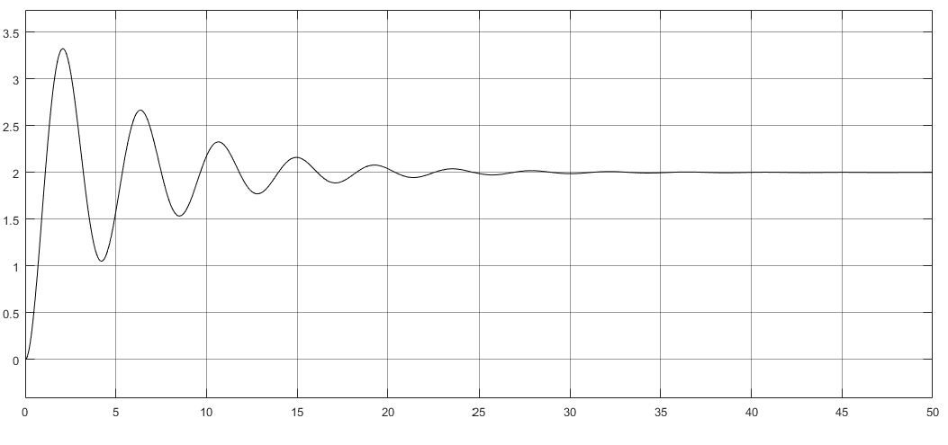number 1 y(t)

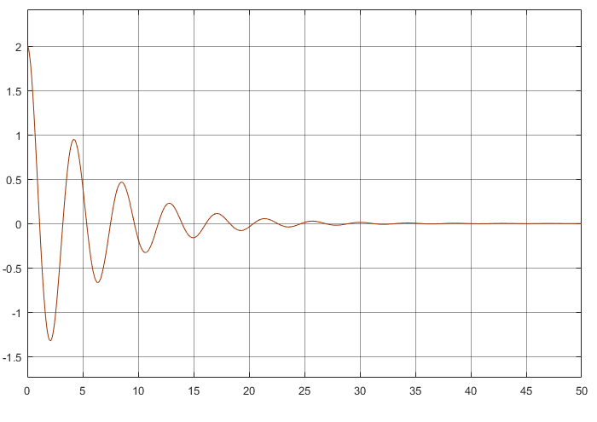number 1 e(t)

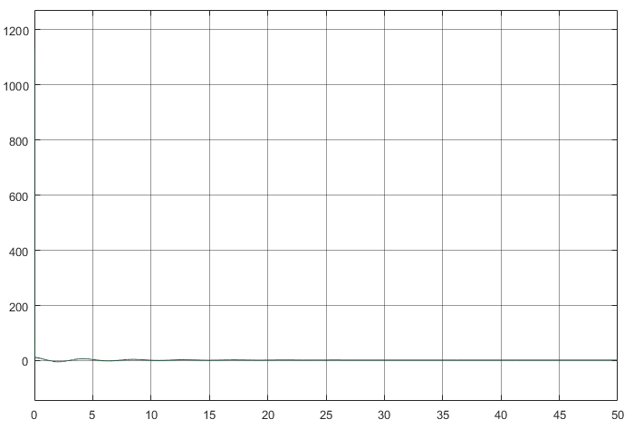number 1 u(t)

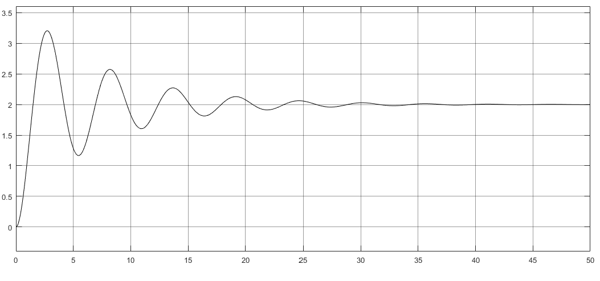number 2 y(t)

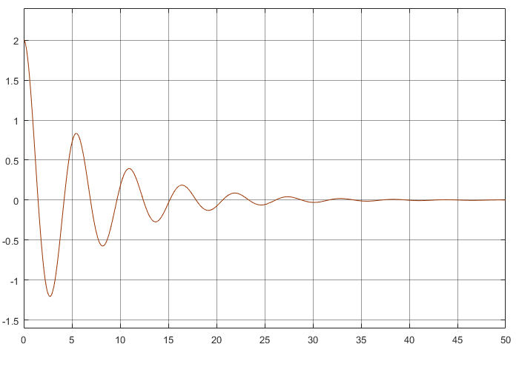number 2 e(t)

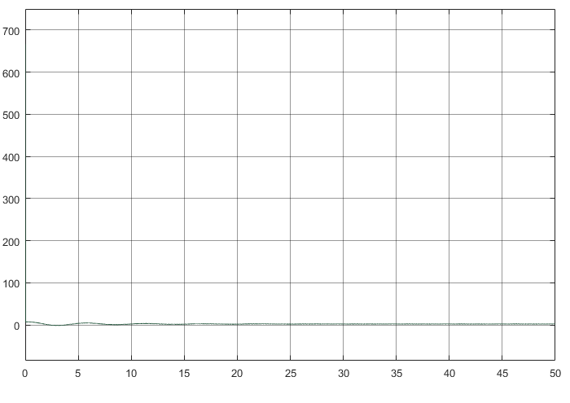number 2 u(t)

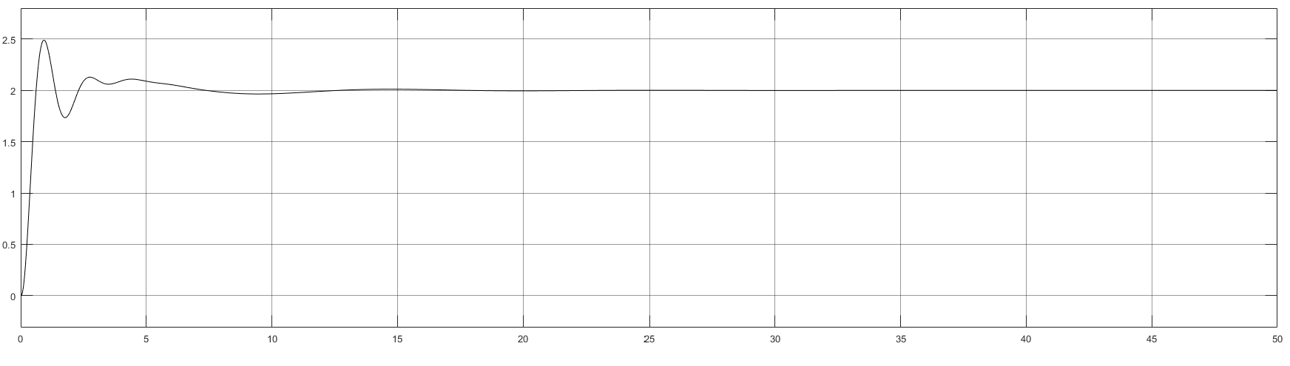number3 y(t)

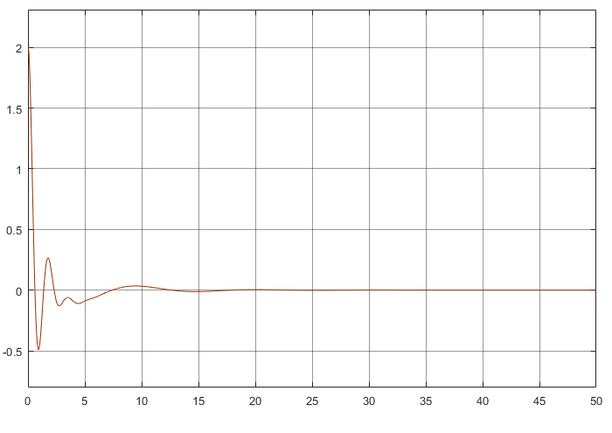number 3 e(t)

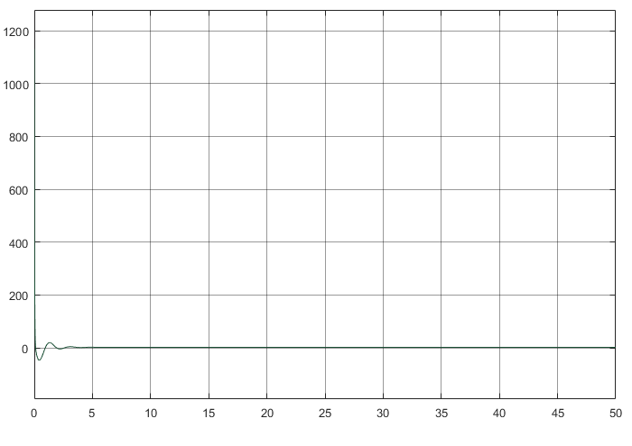number 3 u(t)

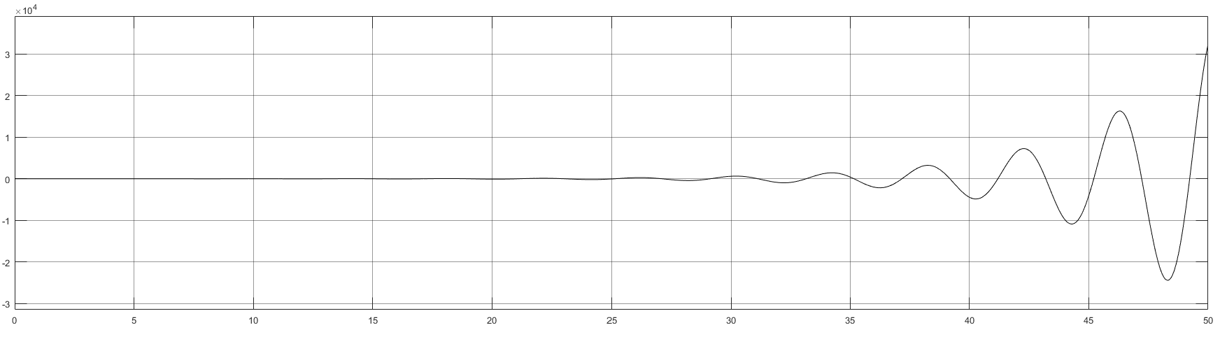number4 y(t)

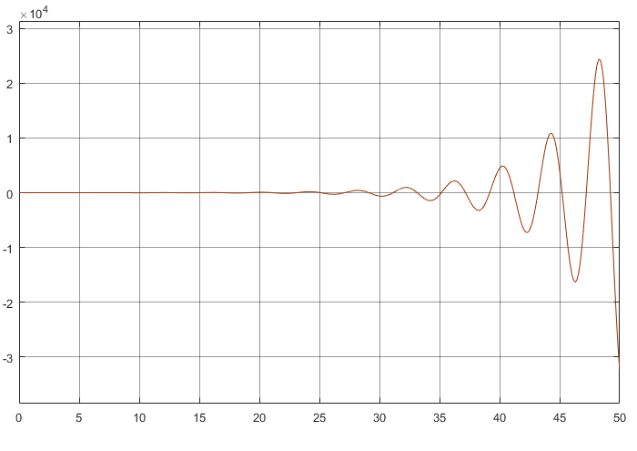number 4 e(t)

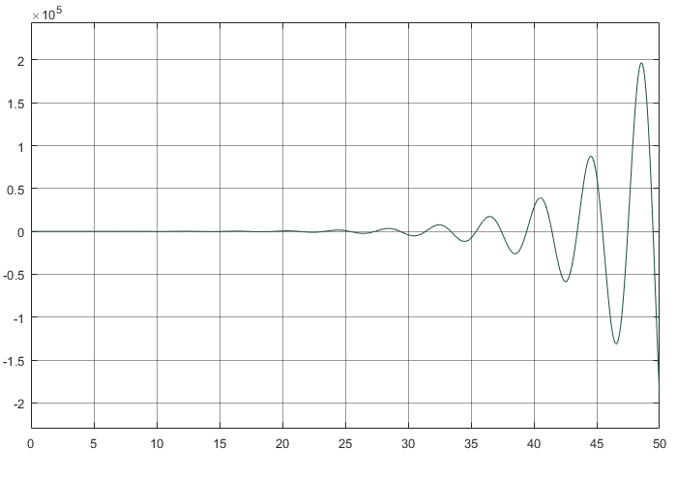number 4 u(t)

Q3.

PID controllers due to having integrator and divider at the same time, increase the stability and the speed of our system but as we see before too much increasing of $k_{i}$ parameters could lead our system to be unstable.